
South Hill Connection Quick News Update
Please share with your friends and neighbours.

Come and join us for a fun evening at the hall. Suitable for ages 8 years and above.
Blood on the Red Carpet is not your usual murder mystery, think Panto meets Traitors with bits & Cluedo thrown in the mix.
Tickets just £10 ……… phone Paula now …………..07977 156966
Guess who’s lying.
Work with your table to solve the crime.
The Parish Hall Golberdon THIS Saturday 28th March.
Enjoy drinks from our bar.
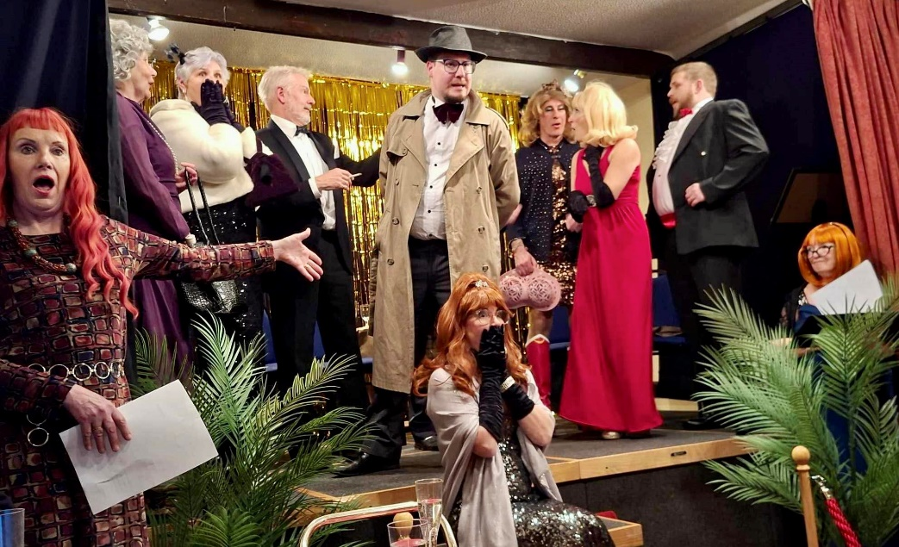
Bring Your Own Nibbles.
Come and join us for a night of suspense, laughter, and shocking twists.
Think you can crack the case?

Look out a lot of Tractors will be on the road April 3rd.






Work at the Community Orchard has moved forward…. If anyone would like some sunflower seeds to pot up and then plant at the orchard, let Ali know. 07305 044049
If you have spare rhubarb or plants for the orchard let Ali know.
To be involved with this project, dates will posted on the Orchard gate and on our South Hill Parish FB group with all other news. www.facebook.com/groups/southhillparish

That’s it for now. Thank you.

